RF and Millimeter-Wave Circuit Design

**Wireless Tin Can Telephone - System Analysis**

Prepared By

* Shenal Ranasinghe

Date of Submission,

* 2024/06/20

**Derive System Specifications from the Problem Definition**

* Problem Definition:
  + You want to have live, audible, and private communication with your neighbor but cannot use any available ready-to-use communication systems (e.g., cell phone). You need to design a system from specifications to implementation on a breadboard. The device must be simple, portable, and capable of at least a 10-meter range.

* System Specifications:
  + Live Communication: Real-time wireless voice transmission.
  + Audible Communication: Must transmit and receive audio signals in the human hearing range (20 Hz to 20 kHz).
  + Private Communication: Ensuring privacy through dedicated frequency.
  + Range: Should be able to communicate at least within 10 meters
  + Simplicity: Simple to build using common components.
  + Portability: Lightweight and battery powered. So our design need to be a Low power consuming one.
  + Noisy Environment: Should be able to withstand reasonable noise interferenc

**Derive System Requirements from the Specifications**

* **System Requirements:**

1. Live Communication:
   * Low latency transmission and reception.
   * Real-time audio processing.
2. **Audible Communication**:
   * Microphone sensitivity suitable for capturing voice (e.g., condenser microphone).
   * Speaker or earphone with sufficient power for clear audio output.
   * Bandwidth: Sufficient to cover human voice frequencies with clarity (3-4 kHz minimum).
3. **Private Communication**:
   * Use a dedicated AM frequency to avoid interference.
4. **Range**:
   * RF transmitter and receiver capable of 10-meter range.
5. **Simplicity**:
   * Use off-the-shelf analog components (microphone, amplifiers, RF modules).
   * Simple modulation scheme (AM).
6. **Portability**:
   * Battery-powered.
   * Low power consumption components. Otherwise we wont be able to use it for a longer period because batteries will drain out quickly. The defined target of the DC Power consumption (PDC) is PDC < 1W.
7. **Noisy Environment**:
   * Starting with target of SNROUT ≥ 40 dB

**Choose Adequate System Architecture for the Wireless System**

* **System Architecture:**

The same architecture which was provided in the lecture series will be used in here

* **System Architecture - Transmitter:**

**Deciding Which bandwidth to use:**

* When deciding the bandwidth we have few options.
  + 3 – 4 KHz
  + 15 – 20 KHz
  + 30 – 50KHz
* Since we’re not trying to send music or something that needs high fidelity there is no need to use 30 – 50 KHz.
* So, we’re now left with 2 options. We know that 3 – 4 KHz is the bare minimum requirement for proper communication and enough to send voice. But it makes our Filter design Bit Complex.
* ***A calculator with different colored text

  Description automatically generatedSo, in order to avoid complex filter design and have a good audio quality I decided to use 15KHz as the bandwidth.***

**Deciding Which Microphone to Use:**

There are several microphones to choose from. Such as,

* + Dynamic Microphones
  + Electret Condenser Microphones
  + Electret Microphones
  + Ribbon Microphones

But for our project, which involves designing a portable, live, audible, and private communication system over a 10-meter range, a **Electret** **condenser microphone** is likely the most suitable choice

**Why a Condenser Microphone?**

1. **Higher Sensitivity**:
   * Compared to dynamic ones, condenser mics have a higher sensitivity, which means they can pick up quieter sounds more effectively. This is useful to make sure that we have clear audio transmission in a communication system.
2. **Wide Frequency Response**:
   * Condenser microphones typically have a wider, flatter frequency response, making them the suitable option for capturing a full range of audible frequencies, which results in good quality.
3. **Voltage Levels**:
   * The peak voltage output of condenser microphones is suitable for interfacing with audio amplifiers and modulation circuits without requiring excessive amplification. (Typically in the range of 10 to 50 mV)

* ***A close-up of a calculator

  Description automatically generatedSo Finally, the peak Voltage from mic is considered to be 40mV assuming our system will be used for talking only and there won’t be any gigantic sounds.***

**Changes done to the Transmitter in QUCS-S Simulation**

* Since we Changed few parameters of the transmitter, we must change the gain of transmitter section in our QUCS-S Simulation. So, instead of 20dB TX gain now we need a 28dB TX gain.
* Which means 25V/V gain. We need to achieve this by using power amplifier and the base band amplifier of the transmitter.

So, I modified it as below,

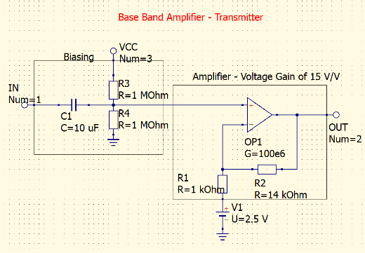

* 10V/V Gain from the baseband amplifier
* Using R1 = 1kOhm and R2 = 14kOhm

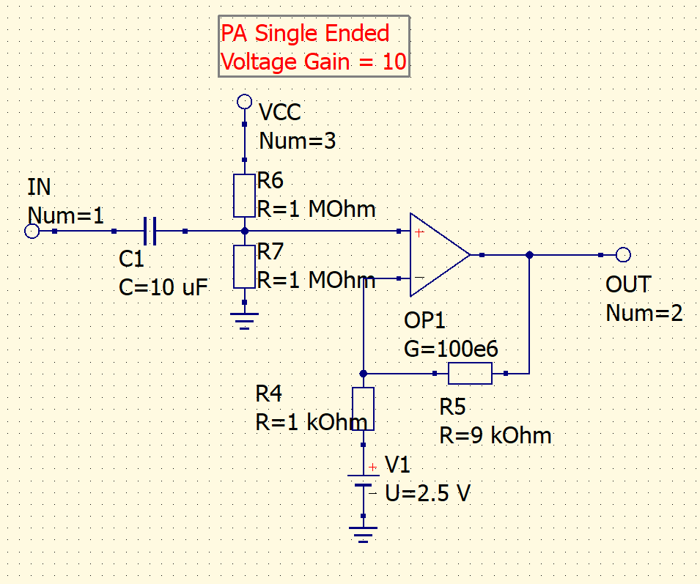

* 15V/V Gain from the Power Amplifier
* Using R5 = 9kOhm and R4 = 1kOhm

**System Architecture- Channel:**

* Blockers (from AM station) = 30 dBm at 600 kHz, 10 Vp (Changed the interference frequency)
* Path Loss (from two loop antennas 10 meters apart) = 70dB
* Man-made noise = 55 dB

* **In order to simulate the 600Khz interference signal I changed it here in QUCS-S**

**System Architecture- Load:**

When it comes to the load, here we have to make a wise decision.

There are wide range of load impedances to choose from,

1. 4 Ohm
2. 8Ohm
3. 16Ohm

So, how are we going to select the speaker that were going to use?

We cant use 4 Ohm speakers because of high current usage.

And 16 Ohm speakers are rarely used.

***So, the best option is to use 8 Ohm speakers***. They give balanced output, they’re compatible with most of the Op-Amps , and they’re power efficient

***Here I changed the Power margin to 4dB.***

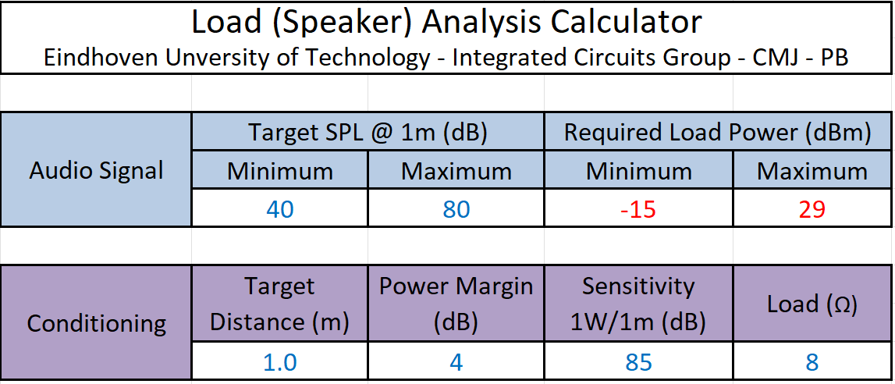

**System Architecture- Receiver:**

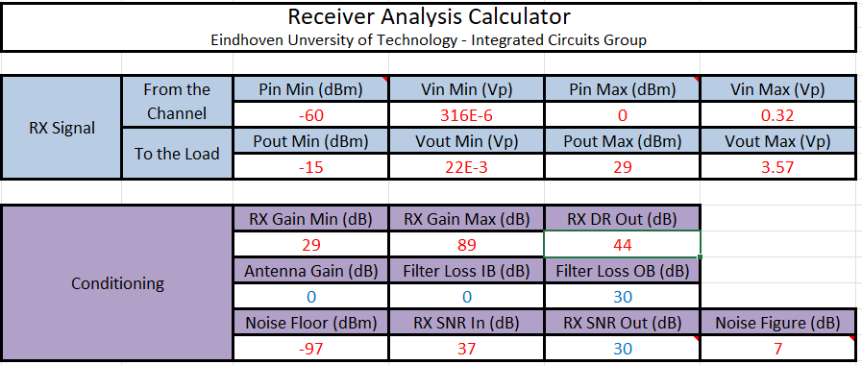

**Derive Important Sub-System Requirements**

